 | IQVIATM Work Instruction Unblinding
Document Number and Revision:
CS_WI_BS003 Revision 14
Document Owner:  Carrie Eason | Author(s):  Ellen Hermes

PURPOSE
To describe the process for full or partial unblinding for statistical analysis of blinded projects.

SCOPE

  - This Work Instruction (WI) applies to all projects globally where IQVIA Biostatistics:
Perform unblinded analyses for a post-database lock deliverable when the Statistical Team Lead (STL) and project team can be unblinded
Perform unblinded analyses for a planned pre-database lock deliverable when the STL and project team must remain blinded
Perform blinded analyses for an open label study

ROLES AND RESPONSIBILITIES
The following roles perform tasks described within this WI:

Role | Sections
Statistical Team Lead (STL) or designee | 6.1, 6.2, 6.3, 6.4, 6.6, 6.7
Unblinded Biostatistician (UB)¹ | 6.2, 6.3, 6.4, 6.5
Project Leader (PL) / unblinded PL² | 6.3
Randomization Biostatistician (RB)³ | 6.2, 6.4
Unblinded Quality Control (UQC) Reviewer⁴ | 6.4
Biostatistics Project Team Member (BPTM) | 6.7
Notes:
¹ UB required for any planned unblinded analyses where the STL must remain blinded. This role is also defined in CS_WI_BS009 (Interim Analyses) and CS_WI_BS002 (Randomization). This role and the role of Randomization Biostatistician (RB) may be performed by the same person.
² For Early Clinical Development (ECD) projects, the Clinical Project Manager (ECD CPM) will be responsible for the PL tasks.
³ Applicable if IQVIA produced the randomization schedule. This role and the role of UB may be performed by the same person.
⁴ Applicable if IQVIA produced the randomization schedule.

DEFINITIONS
Analyses performed prior to database lock: All analyses performed prior to database lock that require some or all of the study data to be fully or partially unblinded but where the STL must remain blinded. Also all analyses performed prior to database lock that require to maintain the blind (or create a dummy randomization) for some or all of the open-label study data. This includes, but is not limited to, interim analyses and analyses provided for a Data Monitoring Committee (DMC), Safety Monitoring Committee (SMC), Independent Data Monitoring Committee (IDMC) or Data and Safety Monitoring Board (DSMB) meetings.
Analysis performed post database lock: Analyses performed once the database has locked for the blinded phase of the study and the STL and project team are no longer required to remain blinded.
Central Randomization Production Tracker: A spreadsheet filed on ELVIS containing the following information for all randomization schedules produced by IQVIA RBs:
- Customer name
- Indication
- Protocol Name / Number
- Project code
- Type of randomization schedule generated (draft, dummy, actual)
- Name and location of RB
- Name and location of UQC / Unblinded Senior Biostatistical (USB) Reviewer
- Name and location of UB (if applicable)
- Date and time of generation of randomization schedule
- Date and time of distribution of randomization schedule
- Network location of randomization specification
- Network location of randomization schedule
- Date and time of each release of randomization schedule for unblinded analysis.
Fully unblinded: Disclosure of the randomized treatment for each subject including the actual name of the treatment.
Partially unblinded: Disclosure of the randomized treatment for each subject but masking the treatment name by use of labels such as “Drug A” or “Drug B”.

MATERIAL AND EQUIPMENT
Not Applicable

PROCEDURE
The summary workflow diagrams for this WI are in Appendix A (Unblinding Workflow). These diagrams do not replace the following text, but rather provide an overview to assist in executing the process.

  - Production of Unblinding Plan

No: | Who: | Step: | When:
6.1.1 | STL | Obtains the final protocol. | Before producing the Unblinding Plan
6.1.2 |  | Defines the process for unblinding a study and writes the Unblinding Plan using CS_TP_BS0201 (Unblinding Plan template).  Note: This must be completed prior to the first planned data transfer from Data Management, even if the only planned unblinded analysis is the final analysis post-database lock. | Prior to the first planned data transfer from Data Management
 |  | In case of any unplanned request of unblinding information (e.g. by third-party vendors) amend the Unblinding Plan to account for the new request.
 |  | An Unblinding Plan must also be created for open label studies which require a blinded analysis, refer to CS_WI_BS0236, Handling Randomization Material in Open Label Studies.
6.1.3 | STL | Distributes the Unblinding Plan to Customer / UB / RB for review and authorization.

  - Review and Authorization of Unblinding Plan

No: | Who: | Step: | When:
6.2.1 | RB, UB | Reviews the Unblinding Plan according to CS_WI_BS015 (Approaches to QC). | Prior to authorization
6.2.2 | RB, UB, STL | Authorizes the Unblinding Plan. | After the review
6.2.3 | STL | Files the Unblinding Plan in the electronic Trial Master File (eTMF). Refer to CS_WI_BS0237 (Management and Filing of Biostatistics Documentation) for processes related to filing. | After authorization

  - Requesting Study Unblinding for Analyses
The following must be performed by the STL or UB (for any unblinded analysis where the STL is to remain blinded).

No: | Who: | Step: | When:
6.3.1 | STL or UB  as appropriate | Completes the applicable section of CS_FM_BS003 (Unblinding Request Form), verifying that all pre-requisites have been met. For post-database lock unblinding the pre-requisites are:  - final, approved Statistical Analysis Plan (SAP).  - locked database and approved analysis sets (if defined in the SAP).  For pre-database lock unblinding the pre-requisites must be documented in the Unblinding Plan. | Prior to receiving the actual randomization schedule

No: | Who: | Step: | When:
6.3.2 | STL or UB  as appropriate | Verifies the applicable section of the Unblinding Request Form is signed by the list of authorizers in the Unblinding Plan. | Prior to receiving the actual randomization schedule
6.3.3 | PL / Unblinded PL | Authorizes all unblinding requests by signing the Unblinding Request Form. | Prior to the unblinding
6.3.4 | STL or UB  as appropriate | Sends the fully signed Unblinding Request Form section to the RB or third-party vendor or Customer who produced the randomization schedule. | Prior to receiving the actual randomization schedule
6.3.5 | STL or UB  as appropriate | Additionally completes any unblinding request documentation required by the third-party vendor or Customer if a third-party vendor or Customer produced the randomization schedule. | As requested by the third party-vendor or Customer
6.3.6 |  | Archives dummy randomization datasets used in deliveries of blinded analyses or deletes dummy randomization datasets used in program development prior to receiving the actual randomization schedule. | Prior to receiving the actual randomization schedule

  - Processing Study Unblinding Requests
Applicable if IQVIA produced the randomization schedule.

No: | Who: | Step: | When:
6.4.1 | RB | Checks the applicable section of CS_FM_BS003 (Unblinding | Prior to
 |  | Request Form), is complete and has been authorized when releasing | transfering the
 |  | randomization schedules within IQVIA. | actual
 |  |  | randomization schedule
6.4.2 |  | Checks the applicable section of CS_FM_BS003 (Unblinding Request Form) or suitable alternative has been completed and
 |  | authorized when releasing randomization schedules to third-party
 |  | vendors.
6.4.3 |  | Locates the randomization schedule.
6.4.4 |  | Prepares to distribute copies according to format, method and
 |  | recipient list specified in the Unblinding Plan.
6.4.5 |  | Arranges an UQC Reviewer.
6.4.6 | UQC | Verifies the correct material is to be distributed and the recipients are
 | Reviewer | correct according to CS_WI_BS015 (Approaches to QC).
6.4.7 | RB | Distributes copies of the randomization schedule according to the format, method and recipient list specified in the Unblinding Plan. | After authorization

No: | Who: | Step: | When:
6.4.8 |  | Checks that the secure Unblinded Project Directory (defined in CS_WI_BS009 [Interim Analysis]) is used, if request is from UB and file is to be transferred directly to the study area. | for unblinding and UQC Reviewer verification
6.4.9 |  | Enters the date and time (including timezone) of distribution on the Unblinding Request Form.
6.4.10 | RB, UQC  Reviewer | Signs and dates Unblinding Request Form.
6.4.11 | RB, STL | Sends the completed Unblinding Request Form to the STL. | After the Form is signed
6.4.12 | STL | Files Unblinding Request Form in eTMF. Refer to CS_WI_BS0237 (Management and Filing of Biostatistics Documentation) for processes related to filing.
6.4.13 | RB | Updates the Central Randomization Production Tracker on ELVIS.

  - Receipt and Incorporation of the Randomization Schedule for Analyses Performed Prior to Database Lock

No: | Who: | Step: | When:
6.5.1 | UB | Complies with all processes described in CS_WI_BS009 (Interim | Any time
 |  | Analyses). | Interim
 |  |  | Analyses is
 |  |  | required
6.5.2 |  | Files the randomization schedule in the Unblinded Project Directory | After receipt of
 |  | (defined in CS_WI_BS009 [Interim Analysis]). | the actual
 |  |  | randomization schedule
6.5.3 |  | Completes the applicable section of the Unblinding Request Form verifying that all pre-requisites have been met and the randomization
 |  | file(s) are correctly incorporated into the programs.
6.5.4 |  | Verifies the randomization schedule is correctly incorporated into the
 |  | deliverable according to CS_OD_BS0227 (Approaches to QC:
 |  | Appendix G - Quality Gates for Derived Data Specifications and
 |  | Sets).
6.5.5 |  | Signs and dates applicable section of the Unblinding Request Form
 |  | and files this in the secure Unblinded Project Directory (defined in
 |  | CS_WI_BS009 [Interim Analysis]) or unblinded eTMF if available
 |  | prior to release of any deliverable using the randomization file(s).
6.5.6 |  | If applicable, determines if there are any randomization or drug
 |  | dispensing errors impacting the analysis set that were not identified
 |  | at the time of authorization of the analysis sets. If necessary, updates
 |  | the analysis set flag for the Per-Protocol set and follows procedures
 |  | for changes made following unblinding as described in
 |  | CS_WI_BS011 (Analysis Sets).

  - Receipt and Incorporation of the Randomization Schedule for Analyses Performed Post Database Lock

No: | Who: | Step: | When:
6.6.1 | STL | Files the randomization schedule in the project area. | After receipt of
 |  |  | the actual randomization schedule
6.6.2 |  | Completes the applicable section of the Unblinding Request Form verifying that all pre-requisites have been met and the randomization file(s) are correctly incorporated into the
 |  | programs.
6.6.3 |  | Verifies the randomization schedule is correctly incorporated
 |  | into the deliverable according to CS_OD_BS0227 (Approaches
 |  | to QC: Appendix G - Quality Gates for Derived Data
 |  | Specifications and Sets).
6.6.4 |  | Signs and dates applicable section of the Unblinding Request
 |  | Form and files this in eTMF prior to release of any deliverable
 |  | using the randomization file(s). Refer to CS_WI_BS0237
 |  | (Management and Filing of Biostatistics Documentation) for
 |  | processes related to filing.
6.6.5 |  | Determines if there are any randomization or drug dispensing
 |  | errors impacting the analysis set that were not identified at the
 |  | time of authorization of the analysis sets. If necessary, updates
 |  | the analysis set flag for the Per-Protocol set and follows
 |  | procedures for changes made following unblinding as
 |  | described in CS_WI_BS011 (Analysis Sets).
6.6.6 | STL | Requests all completed Unblinding Request Forms from the
 |  | RB and files each form in eTMF. Refer to CS_WI_BS0237
 |  | (Management and Filing of Biostatistics Documentation) for
 |  | processes related to filing.

  - Accidental Unblinding
Applicable in case of potential accidental unblinding related to global Biostatistics team members.

No: | Who: | Step: | When:
6.7.1 | BPTM | Take steps to halt the spread of unblinding information. For example, if unblinding information is received via email, delete the email and request all the recipients of that email to not open it and to delete it, if the information is in a file in the study area then delete it, etc.  Send the following message as soon as possible to the unauthorized recipient(s) of unblinding information: Please confirm full deletion (double from your inbox and trash folders or triple from your inbox and trash folders, and purged from the email server) * and please confirm that the data has not been further used, stored or forwarded. | After becoming aware of potential unblinding information

No: | Who: | Step: | When:
 |  | * Depending how the company’s email server is configured.
6.7.2 |  | Informs the line manager or the Biostatistics oversight.
6.7.3 | STL | Investigates if global Biostatistics team membership needs to change due to accidental unblinding.
6.7.4 |  | Documents the identification, assessment, communication and notification to stakeholders using CS_TP_PL0031 (Potential / Actual Unblinding Report) in accordance with CS_WI_PL0029 (Project Management, Communications, and Reporting).

- SUPPORTING DOCUMENTATION
DOCUMENT NUMBER | TITLE
ESOP References
7.1 CS_FM_BS003 | Unblinding Request Form
7.2 CS_OD_BS0227 | Approaches to QC: Appendix G - Quality Gates for Derived Data Specifications and Sets
7.3 CS_TP_BS0201 | Unblinding Plan
7.4 CS_TP_PL0031 | Potential / Actual Unblinding Report
7.5 CS_WI_BS002 | Randomization
7.6 CS_WI_BS009 | Interim Analyses
7.7 CS_WI_BS011 | Analysis Sets
7.8 CS_WI_BS015 | Approaches to QC
7.9 CS_WI_BS0236 | Handling Randomization Material in Open Label Studies
7.10 CS_WI_BS0237 | Management and Filing of Biostatistics Documentation
7.11 CS_WI_PL0029 | Project Management, Communications, and Reporting

- SUPERSEDES
DOCUMENT NUMBER | TITLE | REVISION NUMBER
8.1 CS_WI_BS003 | Unblinding | 13

- MODIFICATION FROM PREVIOUS REVISION
CHANGE | SECTION REFERENCE | JUSTIFICATION
Minor updates to text throughout document | All | Improved consistency across document
Added “Perform blinded analyses for an open label study” | 2.1 | To reduce the risk of sharing unblinded data with teams who are to remain blinded on open label studies

Added “Also all analyses performed prior to database lock that require to maintain the blind (or create a dummy randomization) for some or all of the open-label study data.“ under “Analyses performed prior to database lock” definition. | 4.0 | To reduce the risk of sharing unblinded data with teams who are to remain blinded on open label studies
Updated note for completion of the Unblinding Plan to be prior to the first planned data transfer | 6.1.2 | To align with the “when” description
Removed role of Clinical Project Manager (CPM) and added note 2 | 3.0, 6.3.3 | Role known as Project Leader (PL) only, except in EDC group
Added note to create an Unblinding Plan for open label studies that require a blinded delivery | 6.1.2 | To reduce the risk of sharing unblinded data with teams who are to remain blinded on open label studies
Added reference to CS_WI_BS0236, Handling Randomization Material in Open Label Studies | 6.1.2, 7.0 | For consistency across WIs
Added reference to CS_OD_BS0227, Appendix G - Quality Gates for Derived Data Specifications and Sets | 6.5, 6.6, 7.0 | QC appendix added for clarity
Added message details to prevent the spread of unblinding information | 6.7.1 | To clearly describe the method
Added that STL can perform UB role in open label studies in certain circumstances | Appendix A, Unblinding for Analyses workflow diagram | To align with CS_WI_BS0236, Handling Randomization Material in Open Label Studies

- APPENDICES

  - Appendix A: Unblinding Workflow

Appendix A: Unblinding Workflow
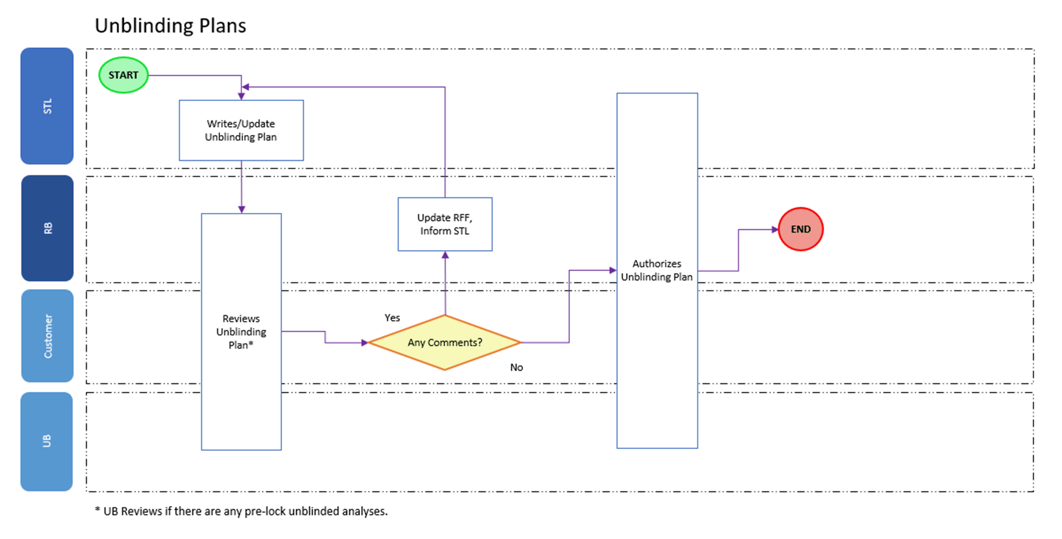

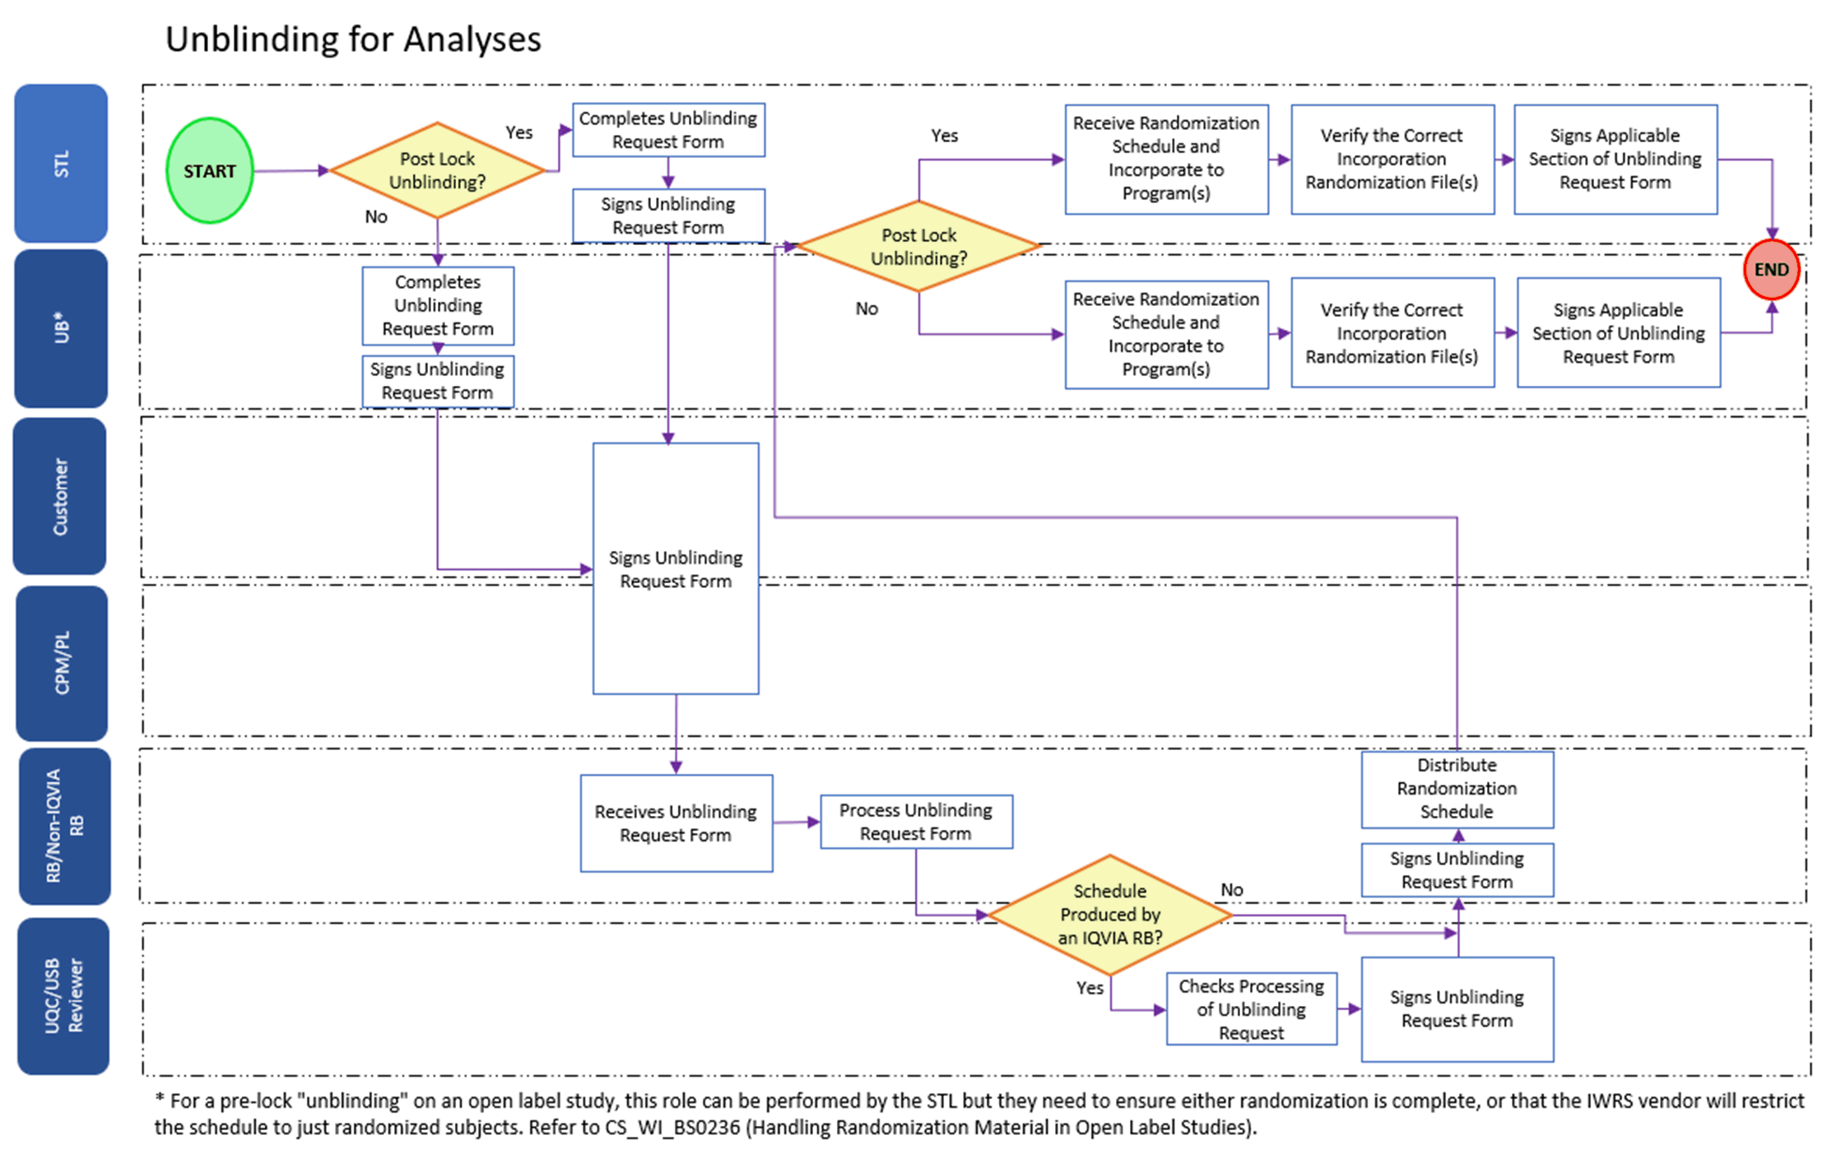

Page 10 of 10
Copyright © 1999, 2000, 2003, 2006, 2008, 2010, 2011, 2014, 2016, 2018, 2020, 2022 IQVIA. All rights reserved. The contents of this document are confidential and proprietary to IQVIA Holdings Inc. and its subsidiaries. Unauthorized use, disclosure or reproduction is strictly prohibited.

Standard Operating Procedure Approval Signature(s)
This is a representation of an electronic record that was signed electronically in Content Server.
This page is the manifestation of the electronic signature(s) used in compliance with the organization’s electronic signature policies and procedures
Refer to Signatories CV for Business Title.

UserName: Bickford, Emma (q637065) Title:
Date: Thursday, 06 October 2022, 06:23 AM Eastern Daylight Time Meaning: Signing this Document Indicates My Approval
================================================

UserName: Ranjan, Santosh (q723916) Title:
Date: Thursday, 06 October 2022, 05:09 PM Eastern Daylight Time Meaning: Signing this Document Indicates My Approval
================================================

UserName: Nufer, Letha (q012496) Title:
Date: Friday, 07 October 2022, 09:33 AM Eastern Daylight Time Meaning: Signing this Document Indicates My Approval
================================================

